**LAB – 16**

1. **Create a 1D array with elements from 1 to 10.**

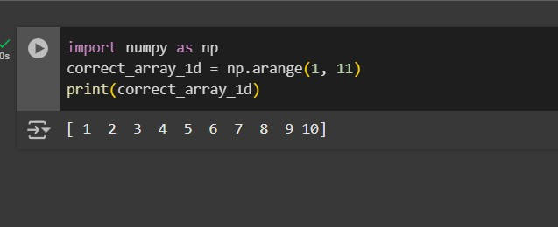

1. **Create a 2D array of size 3x3 filled with zeros.**

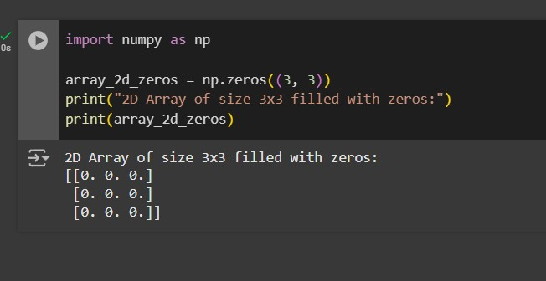

1. **Find the maximum and minimum values in an array.**

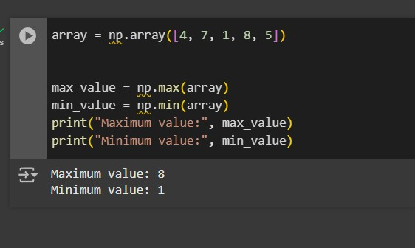

1. **Reshape a 1D array into a 2D array of shape 2x5.**

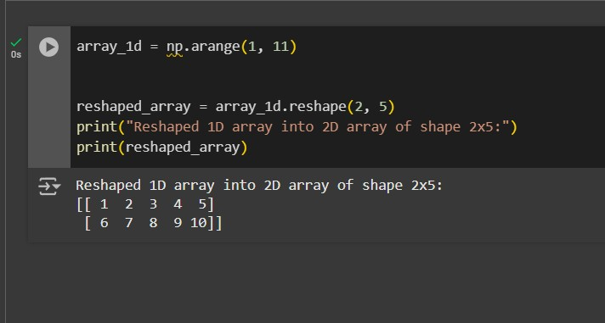

1. **Generate a 1D array of 5 random integers between 10 and 50.**

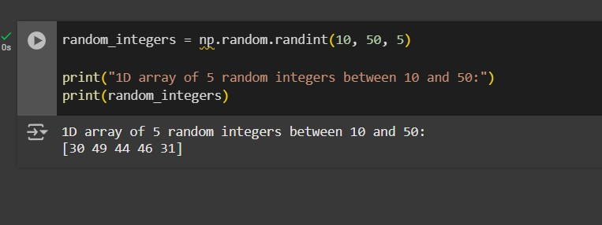

1. **Convert the below list into numpy array then display the array**

**Input: my_list = [1, 2, 3, 4, 5]**

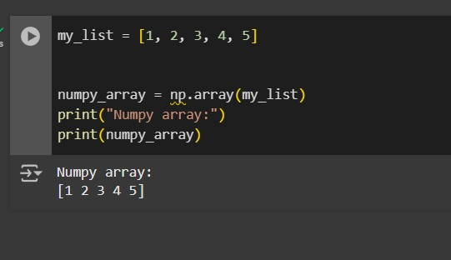

**7. Convert the below list into a numpy array then display the array then display the first and last index and then multiply each element by 2 and display the result.**

**Input: my_list = [1, 2, 3, 4, 5]**

